Malajczuk, George, Dr
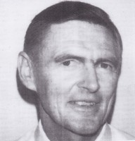
Graduated from Australian Forestry School in 1967. Joined the Forests Department in 1968. Was Officer in Charge of Harvey Working Plans Office in late 1960s. Completed Masters and PhD at Yale in USA in early 1970s. Manager Forests Department/CALM Economics Branch in 1970s-80s. Regional Leader Planning in Northern Forests Region, then principal economist, before appointed Director of Economics in late 1980s. Died 1997 at age 52.

